These holes are not only amazing, but some of them are really terrifying - especially #8! The sheer scale of these holes reminds you of just how tiny you are.
1. Kimberley Big Hole - South Africa
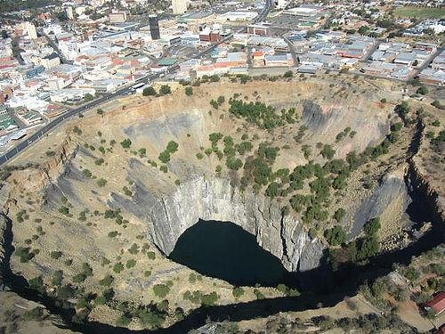
Apparently the largest ever hand-dug excavation in the world,this 1097 meter deep mine yielded over 3 tons of diamondsbefore being closed in 1914.

2. Water Hole - Monticello Dam, California
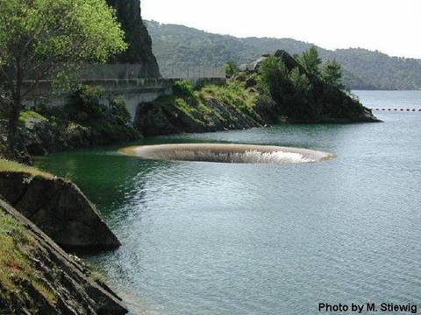
A water hole is used when a dam is at full capacity and water needs to be drained from the reservoir. This is the 'Glory Hole' at Monticello dam, and it's the largest in the world of this type of spillway, its size enabling it to consume
14,400 cubic feet of water every second.
3. Bingham Canyon Mine, Utah
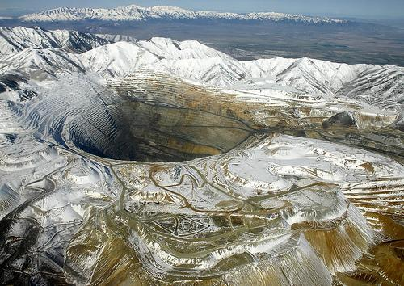
This is supposedly the largest man-made excavation on earth. Extraction began in 1863 and still continues today, the pit increasing in size constantly. In its current state the hole is 2.5 miles wide.

4. Great Blue Hole , Belize
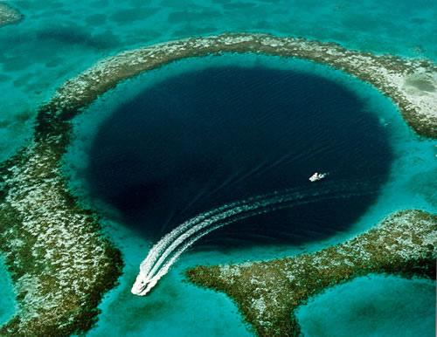
This incredible geographical phenomenon known as a blue hole is situated 60 miles off the mainland of Belize . There are numerous blue holes around the world, but none as stunning as this one.
5. Mirny Diamond Mine , Serbia
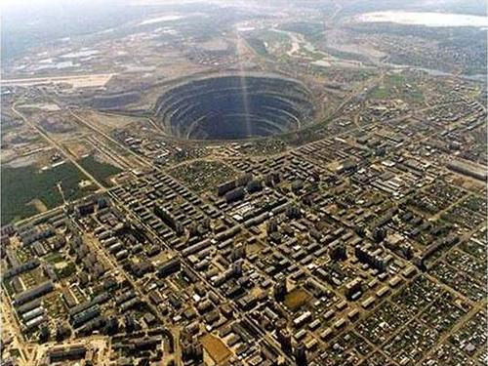
I'm pretty sure most people have seen this one. It's an absolute beast and holds the title of largest open diamond mine in the world. At 525 meters deep with a top diameter of 1200 meters, there's even a no-fly zone above the hole due to a few helicopters having been sucked in.

6. Diavik Mine, Canada
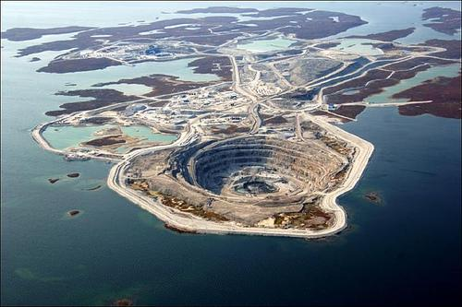
The mine is so huge and the area so remote that it has its own airport with a runway large enough to accommodate a Boeing 737.
It looks equally cool when the surrounding water is frozen.

7. Sinkhole in Guatemala
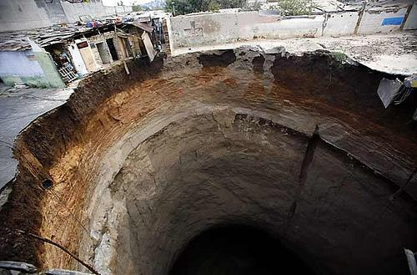
These photos are of a sinkhole that occurred early this year in Guatemala . The hole swallowed a dozen homes and killed at least 3 people.
And the really terrifying one?See #8 below:


This is the famous 'Rat Hole' that you have heard about. It is capable of swallowing trillions and trillions of U.S. dollars... annually!
Never to be heard from again.

