 |  |  |  | These wheels SHOULD fit E60 XI’s EXACTLY
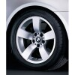 | Star spoke - style 122  ’07 530xi Std Wheel | 8 x 17 | ET 43 | 245/45R17 | Single wheel  Native Chassis | 36116776779  E60 XI
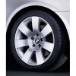 | Star spoke - style 123  07 530xi ETK Optional Wheel | 8JX18 | ET:43 | 245/40 R18W | Single wheel  Native Chassis | 36116767540  E60 XI
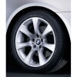 | Star spoke - style 124  07 530xi ETK Optional Wheel | 8JX18 | ET:43 | 245/40 R18W | Single wheel  Native Chassis | 36116775793  E60 XI
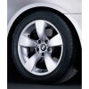 | Star spoke - style 138  07 530xi ETK Optional Wheel | 71/2JX17 | ET:43 | 245/45R17 | Single wheel  Native Chassis | 36116776777  E60 XI
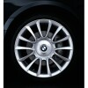 | Star spoke - style 152  07 530xi ETK Optional Wheel  RunFlat Wheel! | 8JX18 | ET:43 | 245/40 R18W | Single wheel  Native Chassis | 36117897258  E60 XI
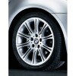 | Star spoke - style 135 | 8JX18 | ET:43 | 245/40 R18W | Single wheel  Native Chassis | 36118036944  E60 XI
 |  |  |  | These wheels from other BMW’s MAY fit E60 XI’s
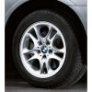 | Double spoke - style 111 | 8 x 17 | ET 46 | 245/45R17 | Single wheel Native Chassis | 36 11 3 401 199  X3 (E83) from 01/2004
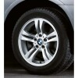 | Double spoke - style 112 | 8 x 17 | ET 46 | 245/45R17 | Single wheel  Native Chassis | 36 11 3 401 200  X3 (E83) from 01/2004
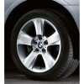 | Star spoke -  style 113 | 8 x 18 | ET 46 | 245/40 R18W | Single wheel Native Chassis | 36 11 3 401 201 X3 (E83) from 01/2004
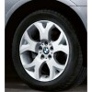 | Y spoke -  style 114 | 8 x 18 Front | ET 46 | 245/40 R18W | Single wheel Native Chassis | 36 11 3 401 202 X3 (E83) from 01/2004
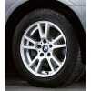 | Double spoke -  style 148 | 8 x 17 | ET 46 | 245/45R17 | Single wheel Native Chassis | 36 11 3 412 060  X3 (E83) from 01/2004
 | M Double spoke - style 135 | 8 x 18 Front | ET 47 | 245/40 R18W | Single wheel  Native Chassis | 36 11 7 896 470  3 Series (E46) from 04/98  except M3 Z4 (E85, E86) from 03/2003
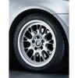 | Cross spoke - style 133 | 8 x 17 | ET 47 | 245/45R17 | Single wheel  Native Chassis | 36 11 6 762 109  3 Series (E36) from 12/90  except M3  3 Series (E46) from 04/98  except M3  Z4 (E85, E86) from 03/2003
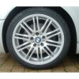 | M Double spoke - style 164 | 7,5 x 18 Front | ET 41 | 235/40 R18W | Single wheel  Native Chassis | 36 11 2 282 590  3 Series (E46)  for M3 and M3 CSL
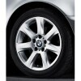 | Star spoke - style 170 | 8 x 17 | ET 47 | 245/45R17 | Single wheel  Native Chassis | 36 11 6 766 740  3 Series (E46) from 04/98  except M3
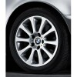 | Star spoke - style 171 | 8 x 17 | ET 47 | 245/45R17 | Single wheel  Native Chassis | 36 11 6 766 741  3 Series (E46) from 04/98  except M3
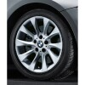 | Turbine styling - style 201 | 8 x 17 | ET 47 | 245/45R17 | Single wheel  Native Chassis | 36 11 6 771 158  Z4 (E85, E86) from 03/2003
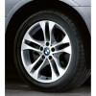 | Double spoke - style 205 | 8 x 18 | ET 46 | 235/40 R18W | Single wheel  Native Chassis | 36 11 3 417 394  X3 (E83) from 01/2004
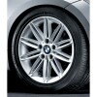 | M Double spoke - style 207 | 7,5 x 17 | ET 47 | 235/45 R17 | Single wheel  Native Chassis | 36 11 8 040 048  1 Series (E81, E87)

