 |  |  |  | These wheels SHOULD fit E60 XI’s EXACTLY
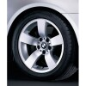 | Star spoke - style 122  ’07 530xi Std Wheel | 8 x 17 | ET 43 | 245/45R17 | - Single wheel : | 36116776779
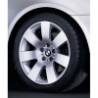 | Star spoke - style 123  07 530xi ETK Optional Wheel | 8JX18 | ET:43 | 245/40 R18W | - Single wheel : | 36116767540
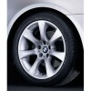 | Star spoke - style 124  07 530xi ETK Optional Wheel | 8JX18 | ET:43 | 245/40 R18W | - Single wheel :
  36116775793
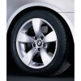 | Star spoke - style 138  07 530xi ETK Optional Wheel | 71/2JX17 ET:43 | ET:43 | 245/45R17 | - Single wheel :
  36116776777
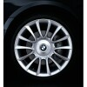 | Star spoke - style 152  07 530xi ETK Optional Wheel  RunFlat Wheel! | 8JX18 | ET:43 | 245/40 R18W | - Single wheel :
  36117897258
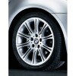 | Star spoke - style 135 | 8JX18 | ET:43 | 245/40 R18W | - Single wheel :
  36118036944
 |  |  |  | These wheels from other BMW’s MAY fit E60 XI’s
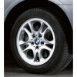 | Double spoke - style 111 | 8 x 17 | ET 46 | 245/45R17 | - Single wheel :  - Hub cap : | 36 11 3 401 199  36 13 6 768 640
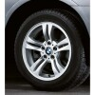 | Double spoke - style 112 | 8 x 17 | ET 46 | 245/45R17 | - Single wheel :  - Hub cap : | 36 11 3 401 200  36 13 6 768 640
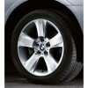 | Star spoke -  style 113 | 8 x 18 | ET 46 | 245/40 R18W | - Single wheel :  - Hub cap : | 36 11 3 401 201  36 13 6 768 640
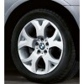 | Y spoke -  style 114 | 8 x 18 Front | ET 46 | 245/40 R18W | - Single wheel, front :  - Hub cap : | 36 11 3 401 202  36 13 6 768 640
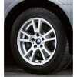 | Double spoke -  style 148 | 8 x 17 | ET 46 | 245/45R17 | - Single wheel :  - Hub cap : | 36 11 3 412 060  36 13 6 768 640
 | M Double spoke - style 135 | 8 x 18 Front | ET 47 | 245/40 R18W | - Single wheel, front :  - Hub cap : | 36 11 7 896 470  36 13 6 768 640
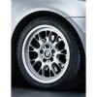 | Cross spoke - style 133 | 8 x 17 | ET 47 | 245/45R17 | Single wheel :  - Hub cap : | 36 11 6 762 109  36 13 6 768 640
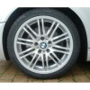 | M Double spoke - style 164 | 7,5 x 18 Front | ET 41 | 235/40 R18W | - Single wheel, front : | 36 11 2 282 590
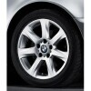 | Star spoke - style 170 | 8 x 17 | ET 47 | 245/45R17 | Single wheel : | 36 11 6 766 740
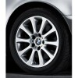 | Star spoke - style 171 | 8 x 17 | ET 47 | 245/45R17 | Single wheel : | 36 11 6 766 741
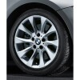 | Turbine styling - style 201 | 8 x 17 | ET 47 | 245/45R17 | Single wheel : | 36 11 6 771 158
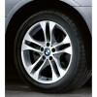 | Double spoke - style 205 | 8 x 18 | ET 46 | 235/40 R18W | Single wheel : | 36 11 3 417 394
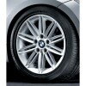 | M Double spoke - style 207 | 7,5 x 17 | ET 47 | 235/45 R17 | Single wheel, rear : | 36 11 8 040 048

