The black with red stripe and black with brown stripe 20ga wire that goes into the stock sub amp are already a "low level" signal. There's no need to wire them to a line-out converter prior to an amp since the purpose of a line out converter is to convert high-level signals (speaker level output) to line level signals. Solder and splice RCA jacks to these wires and you should be fine.
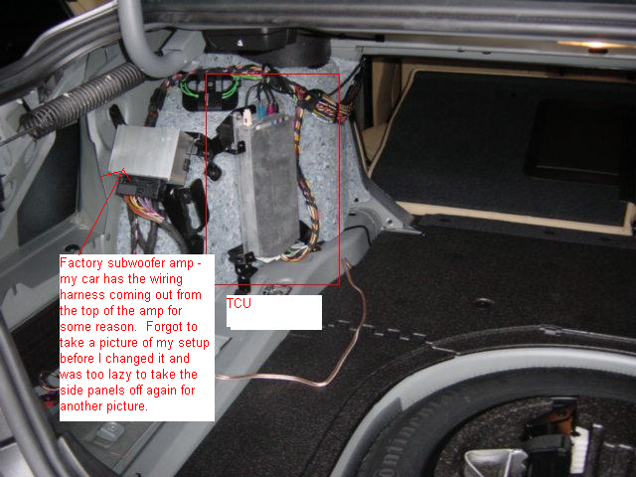
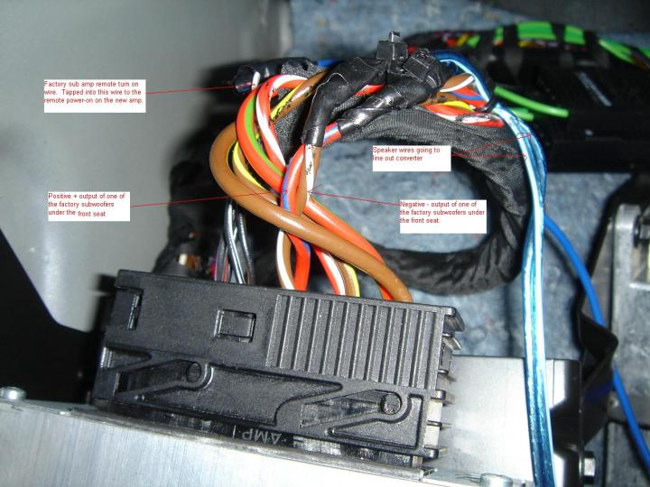
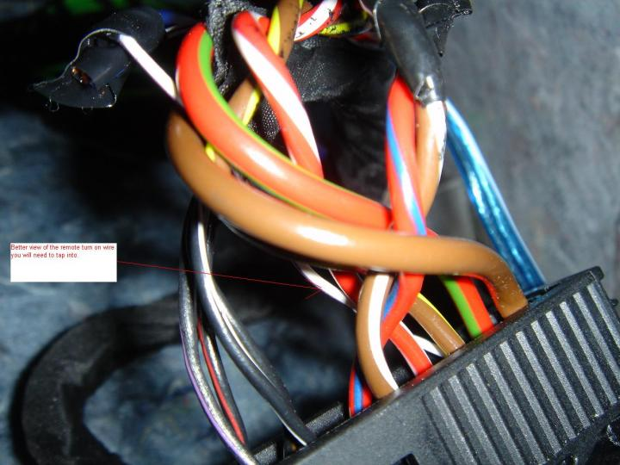
4.0 RT/GN pin 10 +ve [12V+line]
4.0 BR pin 20 -ve [12V-lineor earth]
0.35 WS/VI pin 9 RAD_ON [Remote on]
0.75 SW/VI pin 13 AZBL- [Line level Left input -ve]
0.75 SW/RT pin 3 AZBL+ [Line level Left input +ve]
0.75 SW/BR pin 4 AZBR- [Line level Right input -ve]
0.75 SW/WS pin 14 AZBR+ [Line level Right input +ve]
2.5 RT/WS pin 8 ZBL+ [Speaker output Left +ve]
2.5 BR/GE pin 18 ZBL- [Speaker output Left -ve]
2.5 RT/BL pin 6 ZBR+ [Speaker output Right +ve]
2.5 BR/WS pin 16 ZBR- [Speaker output Right -ve]
WS = White AZB = Line Level Outputs
RT = Red ZB = Speaker Connections
GN = Green
BR = Brown
VI = Violet
BL = Blue 2ohms?
SW = Black
GE = Yellow Low Pass Filter if Whine
GR = Gray
