Wiring Diagram Symbols and Wire Colors

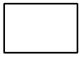 | Entire component shown |  | 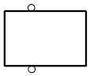 | Component with screw terminals
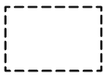 | Part of component shown |  | 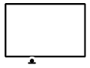 | Component case attached directly to metal part of car (grounded)
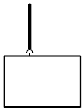 | Connector attached to component |  | 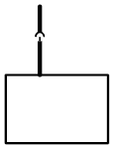 | Connector attached to component lead (pigtail)
Wire Color
 | BL | Blue
 | BR | Brown
 | GE | Yellow
 | GN | Green
 | GR | Gray
 | OR | Orange
 | RS | Pink
 | RT | Red
 | SW | Black
 | VI | Violet
 | WS | White
 | TR | Transparent

 |  | 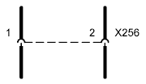 | Two connections (pins in the same connector.  Dashed line indicates terminals of the same connector
 | 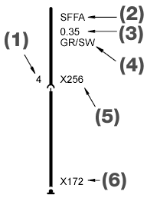 | (1) Pin Number  (2) Signal  (3) Wire size in mm squared  (4) Wire Color  (5) Hotspot Connector Reference Number  (6) Hotspot Ground Reference Number

© BMW Service - WDS BMW Wiring Diagram System - Version 3.0

