 | SI B 63 06 03  Lights | October 2003  Service Engineering
SUBJECT
Headlight Rear Auxiliary Bracket Cracked
MODEL
E60 (5 Series)
SITUATION
The headlight rear auxiliary bracket may be cracked in the area of one of the support bolts.
CAUSE
Bracket is cracked.
PROCEDURE
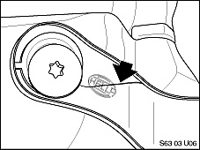 | - Inspect the rear headlight auxiliary brackets for cracks.  - If one side bracket is cracked then replace both rear auxiliary headlight brackets.  - LH Bracket PN 63 12 6 929 307  - RH Bracket PN 63 12 6 929 308
PARTS INFORMATION
Part Number | Description | Quantity
63 12 6 929 307 | Left Bracket | 1
63 12 6 929 308 | Right Bracket | 1

[ Copyright © 2003 BMW of North America, LLC ]

