DIY : Mtech Front Bumper Removal

I thought I would create this DIY as I did not see any thorough instructions on the forum. The TIS documents I looked over were, well terrible, and other posts I found actually did not go into enough detail…..so, here is my DIY. I would say that that job took a total of 3 hours and I worked completely by myself. Mind you that I did not know what I was doing and was working on trial and error. So, if I were to remove it again and put back on, I bet I could finish it in less than 1.5 hours. A body shop wanted $250 to remove the bumper so this was my motivation to figure it out.

I am not going to list all the tools needed because if you need help with this, don’t bother with the install.

Step 1: Remove headlights. This gives you access to the bolts that need to be removed in order to remove your bumper. Removing the headlights is rather easy….what you need are the right tools. You basically need a very long screw driver with the correct torex head. I followed this video and had no issues:

http://www.youtube.com/watch?v=15ght75I-mo

Step 2: Remove the 5 bolts on the top of the bumper….much like you do when you are replacing the kidneys (if you have ever done this). This link will help with that:

http://www.raceprecision.com/forums/viewtopic.php?f=7&t=17

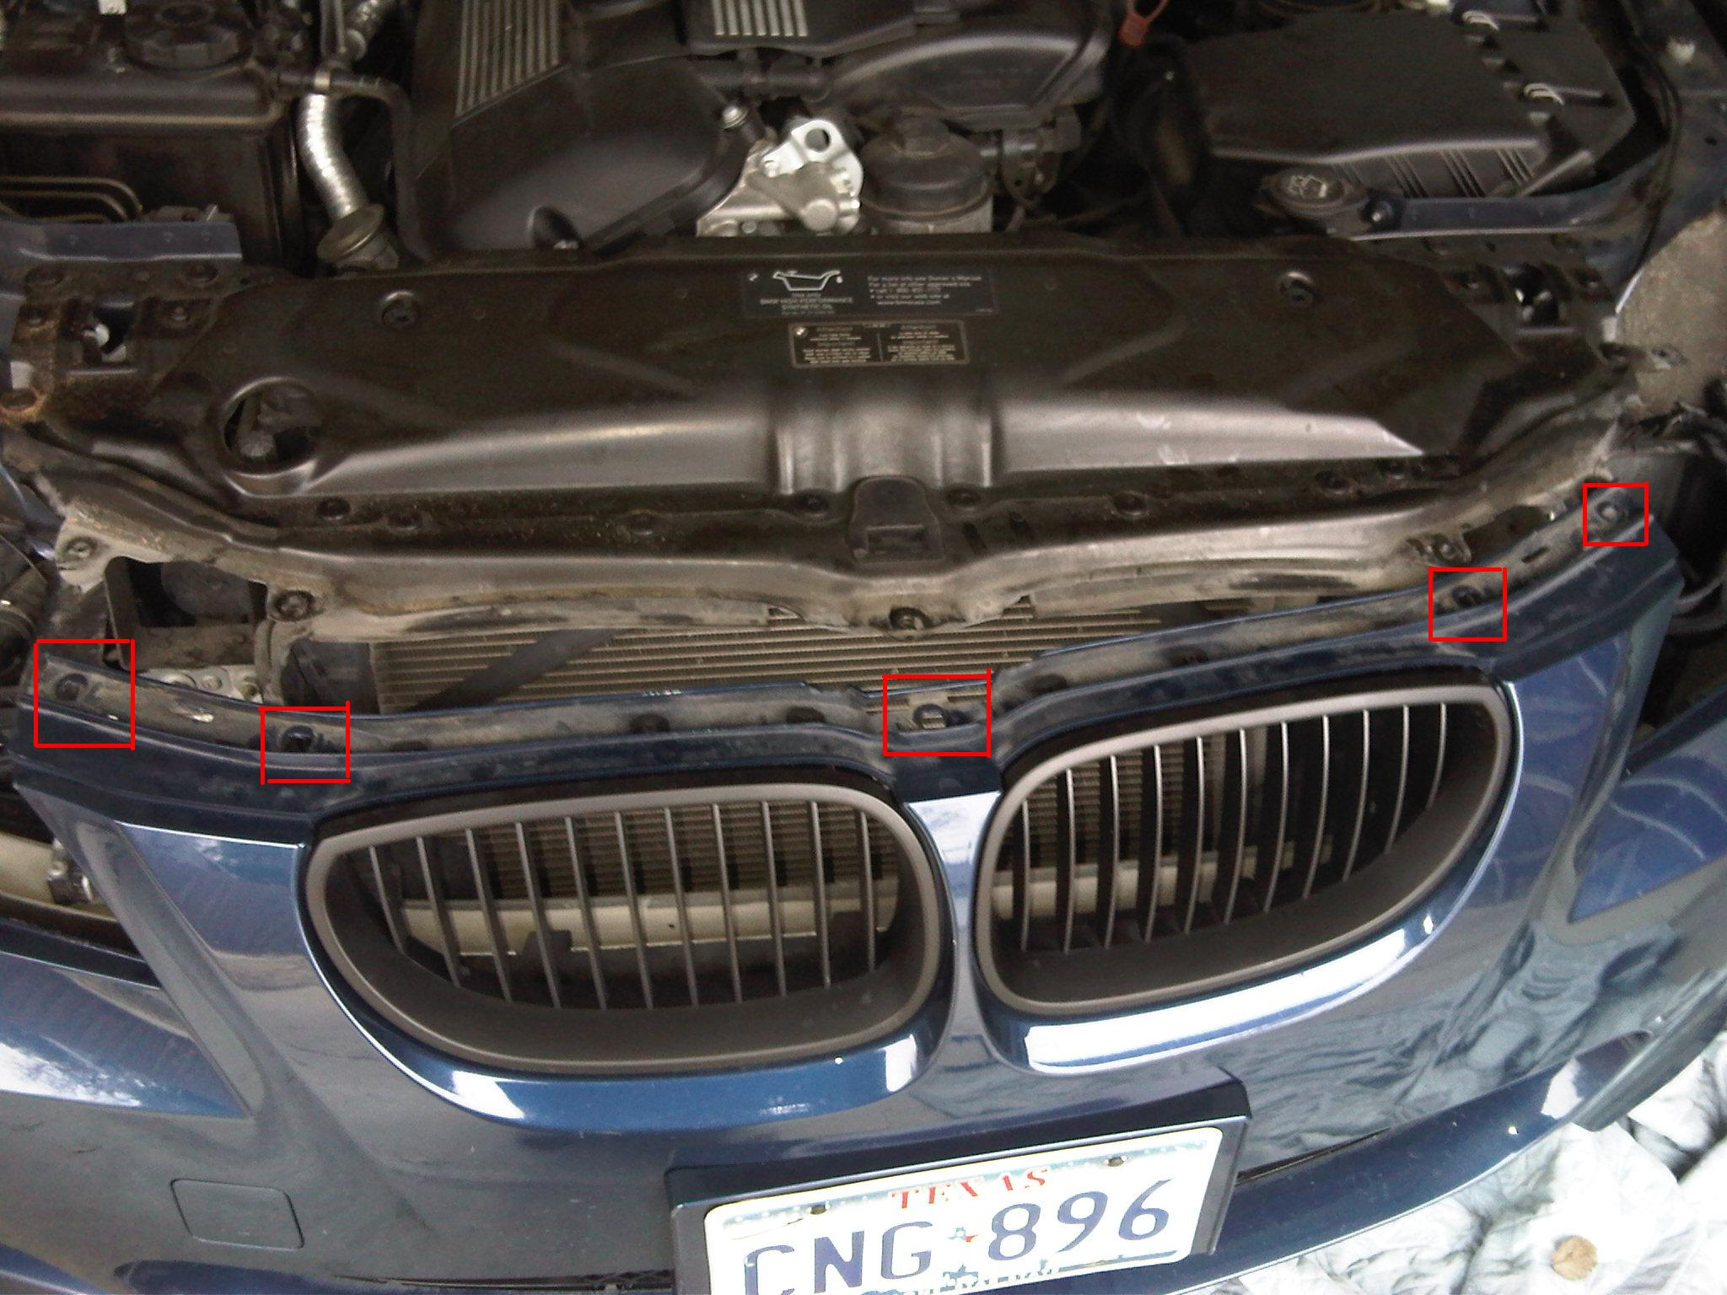

Step 3: Jack up the driver side and remove the tire. NOTE – You do not really have to do this step but I must admit that this is will help you gain access to the wheel well and prevent a tire from getting in your way. Just a suggestion.

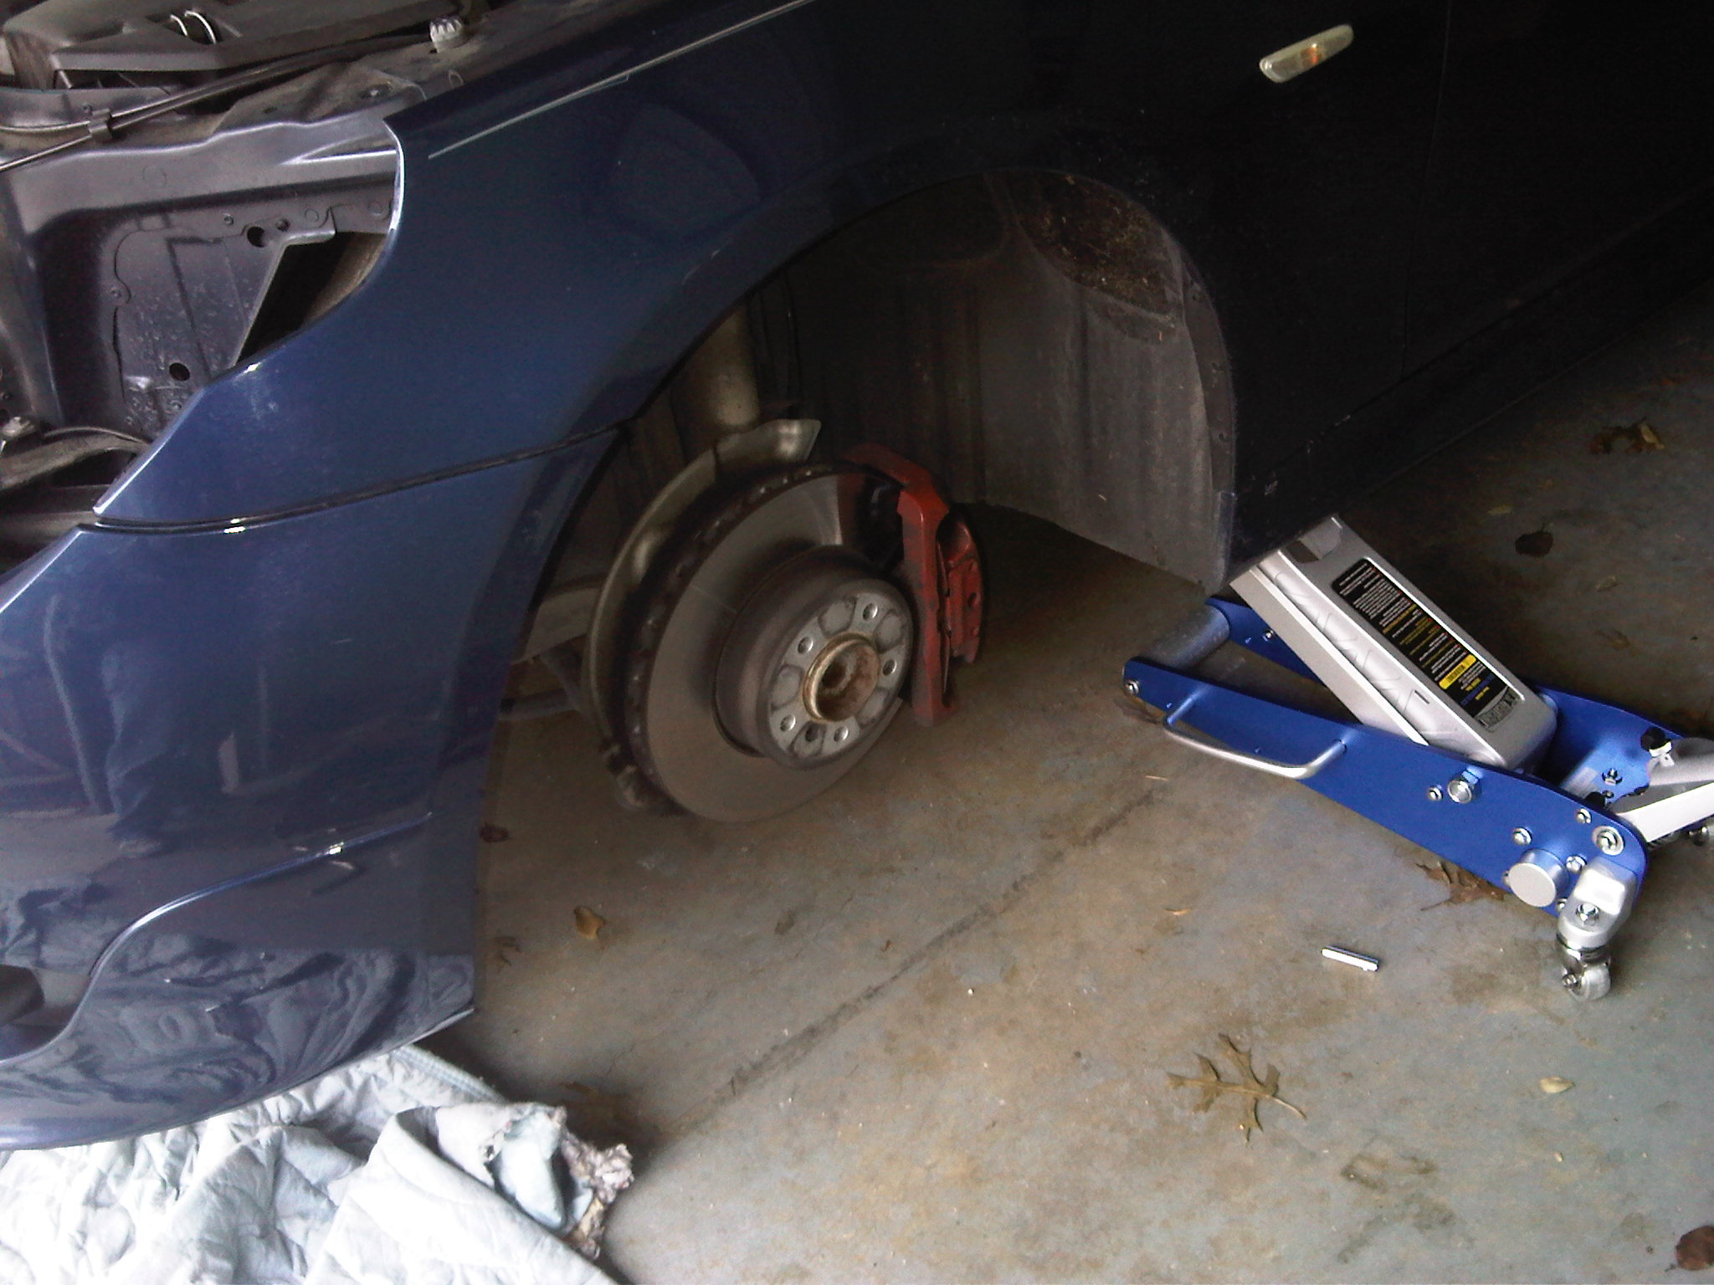

Step 4: Remove three (3) screws on the driver side of the bumper. These screws are located to the far right of the bumper if you are looking at the car head on. These screws attach the bumper to the side fender. This is step where I found NO information on the forum. The TIS docs do not reference these screws so this is where my trial and error kicked in. I literally started pulling on the bumper to see where it was getting caught…this lead me to these three screws. NOTE – To remove these screws is not easy and little hands would be helpful. This is essentially why I removed the tire because the best way to gain access is through the wheel well. Be patient on this step.

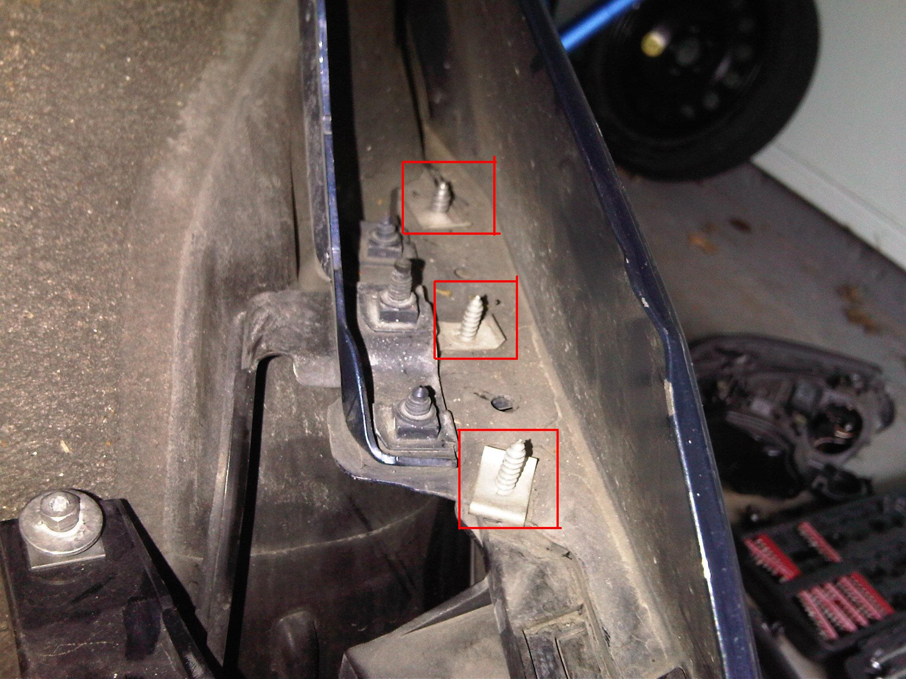

Step 5: Once the three screws are removed, that side of the bumper can be set free. The last step is to remove the clip that is holding the bumper into place.

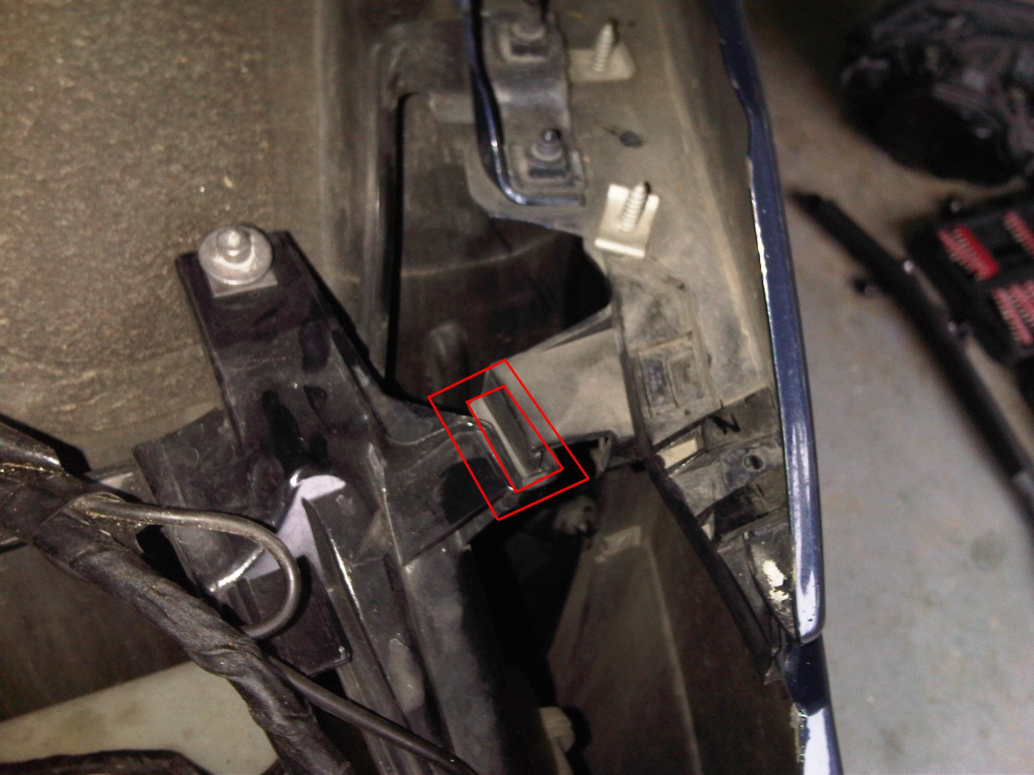

Step 6: Put your driver side tire back on, and complete steps 3, 4, and 5 on the passenger side. Here is a picture of those 3 screws removed on the passenger side:

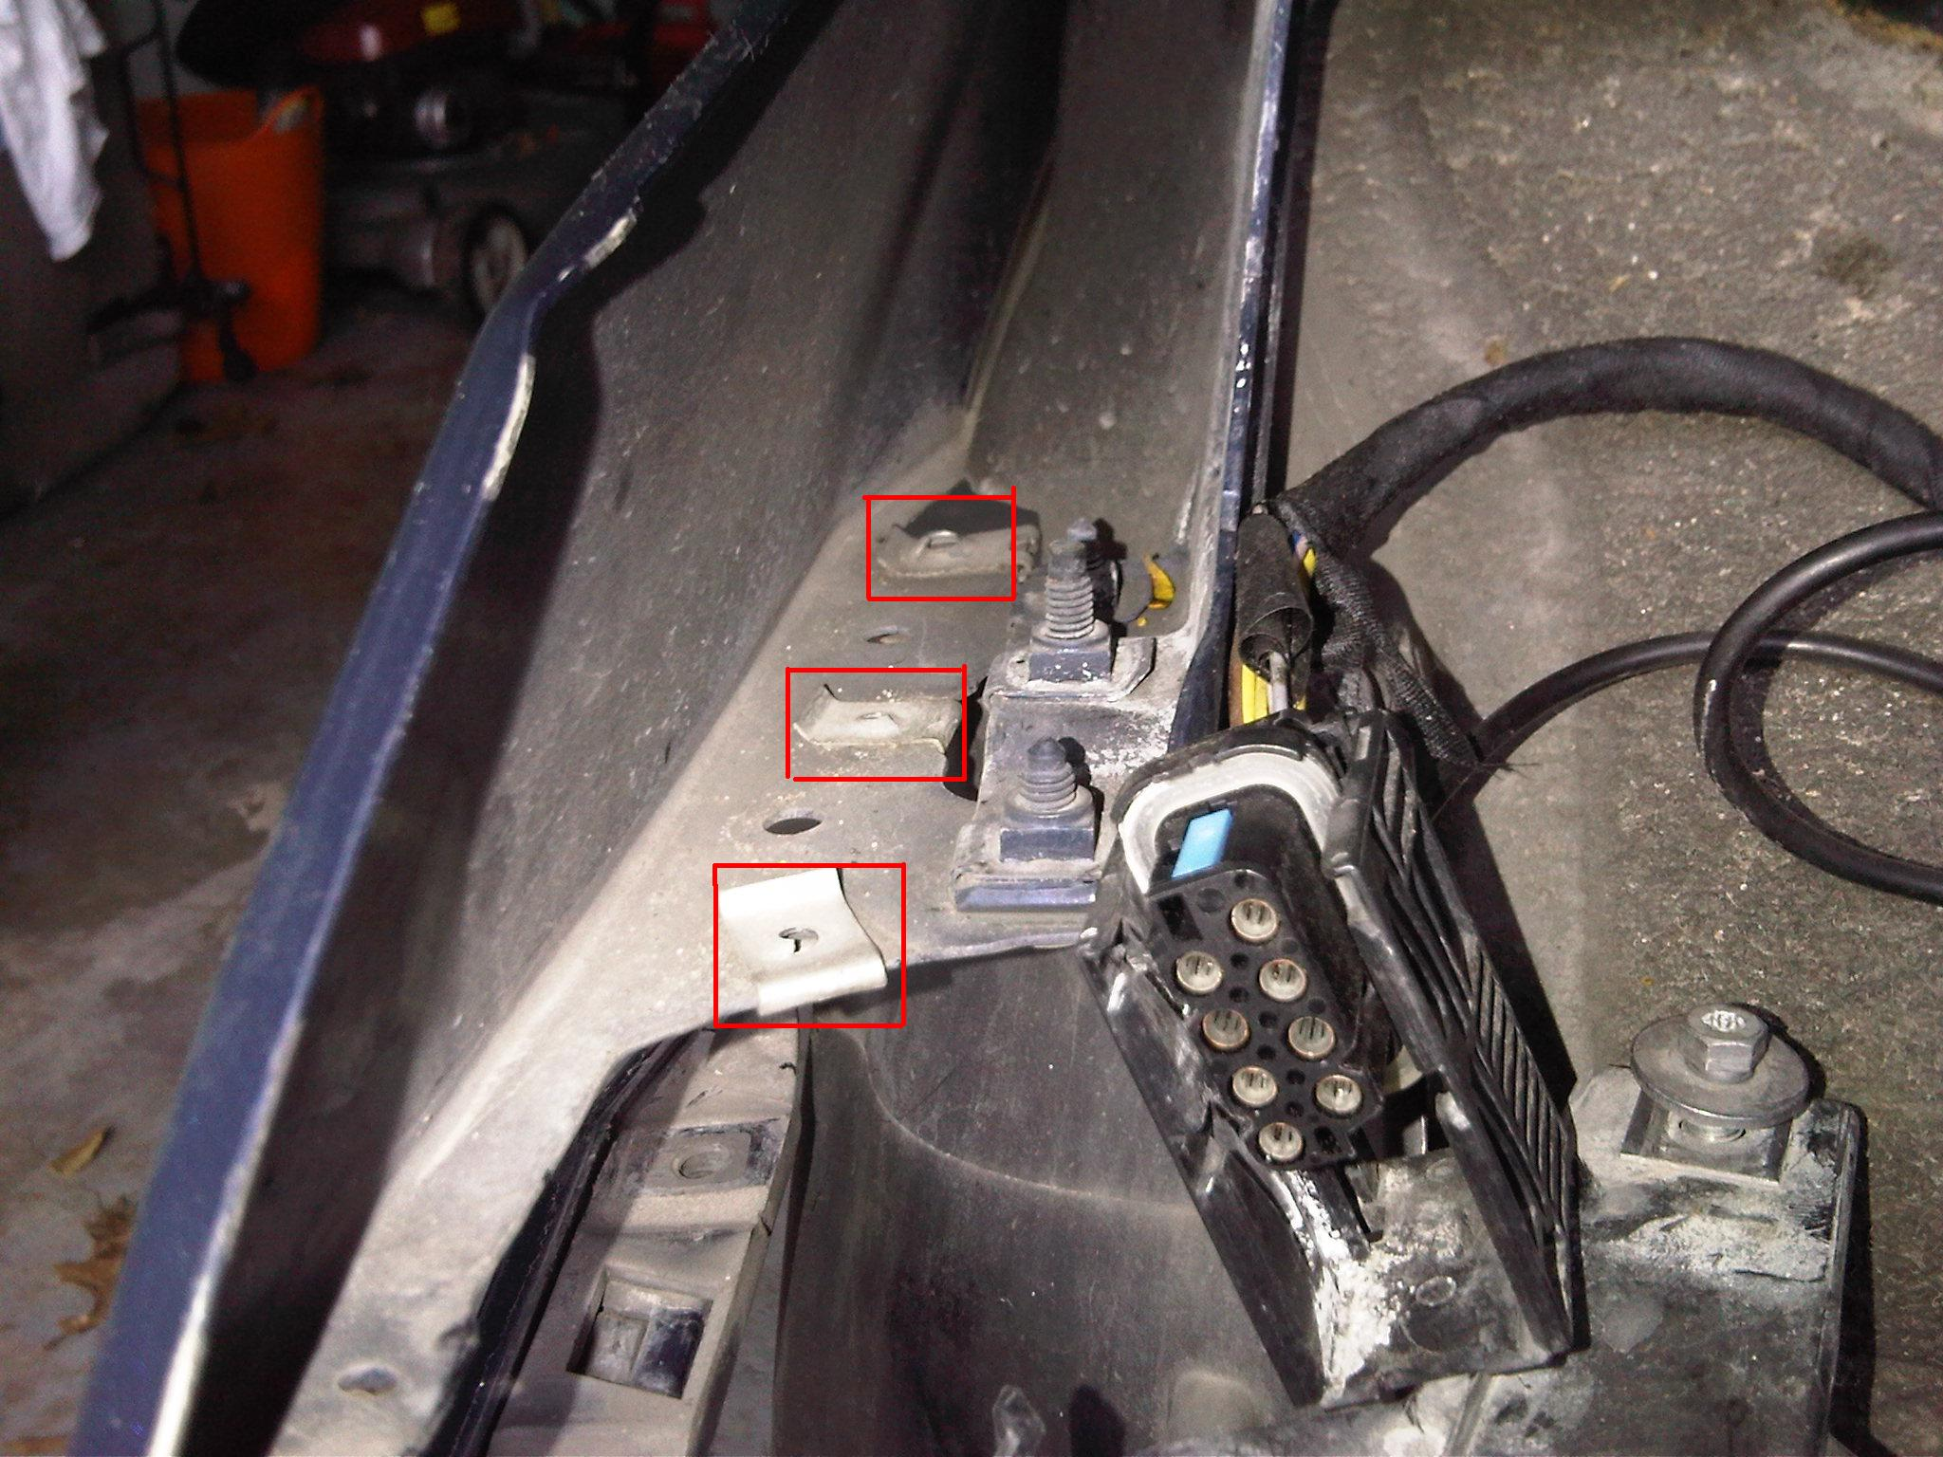

Here is a zoomed out picture of the same side. Note that the clip I reference in step 5 is removed and you can see the bumper basically just hanging there.

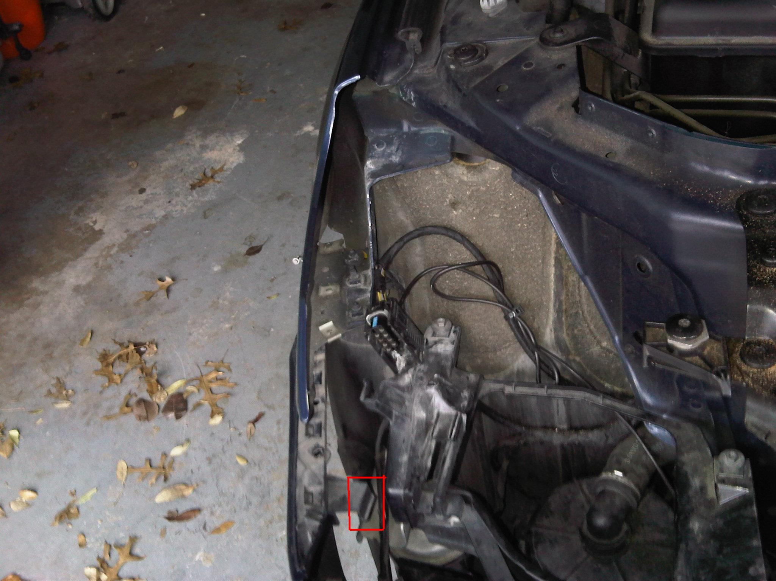

Here is a picture of the bumper removed. The reason I had to remove the bumper was to replace the lower mesh grill (which I highlighted in red below).

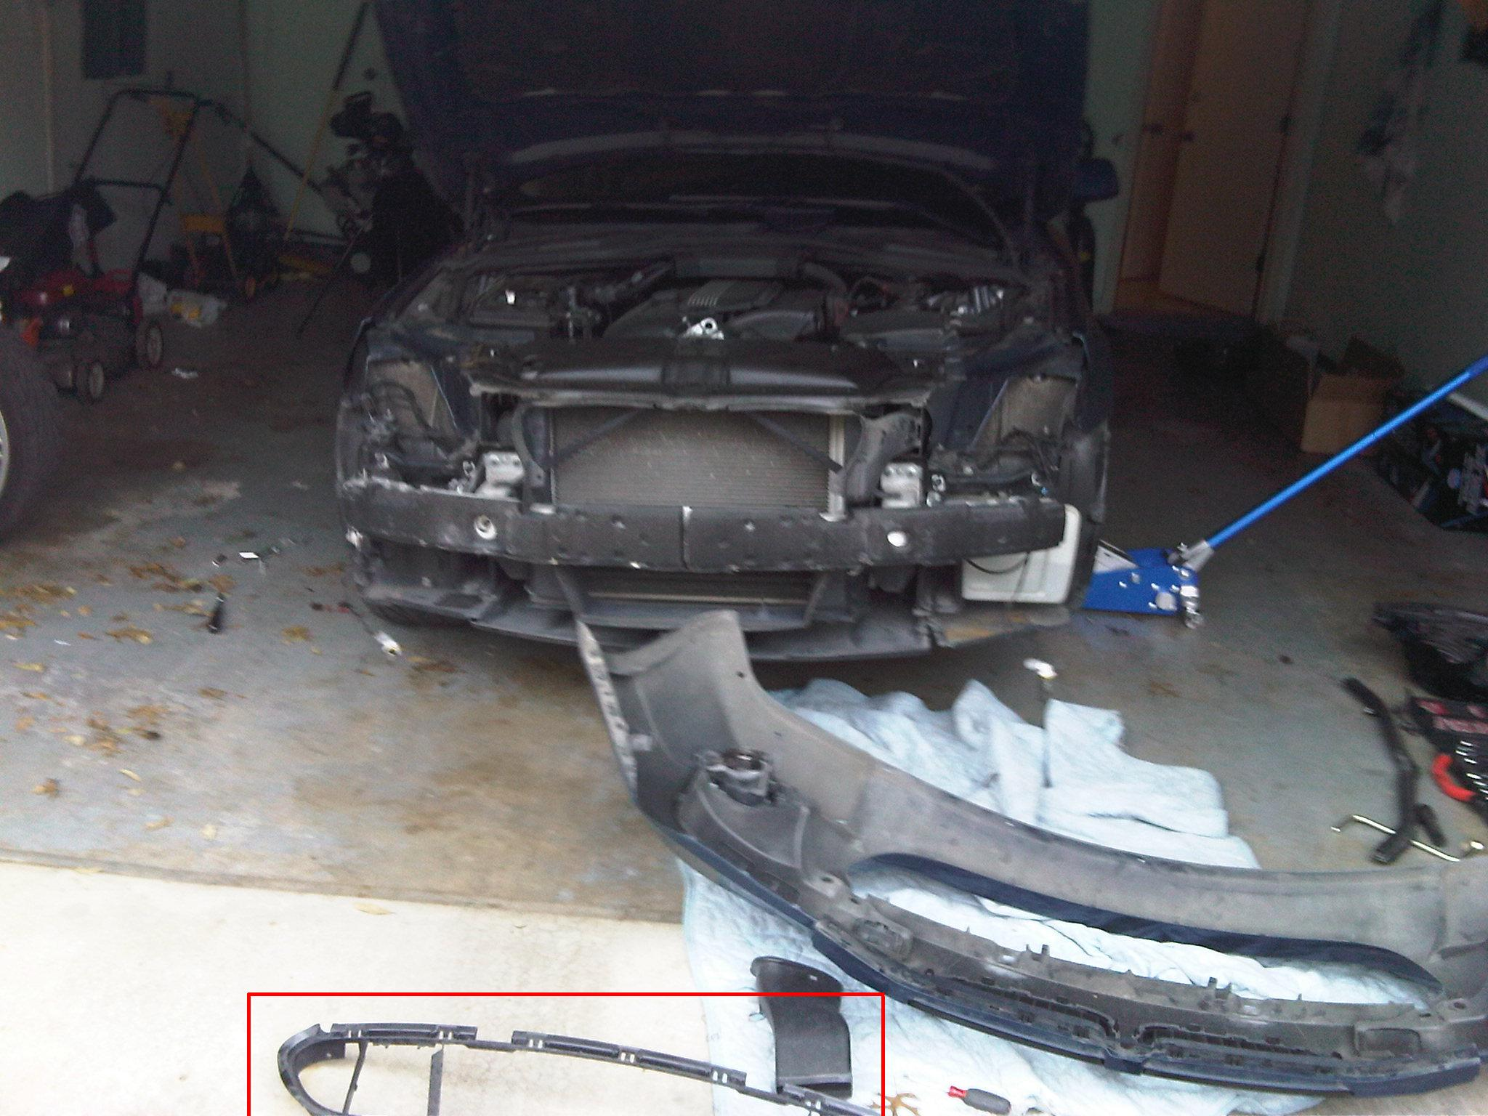

I hope this DIY helps those down the road. I always think it is important to be able to learn how to remove your bumper….just in case.

Let me know if anything doesn’t make sense and I will try to elaborate.

Thanks!

